10 W Gearbox Integrated Motor
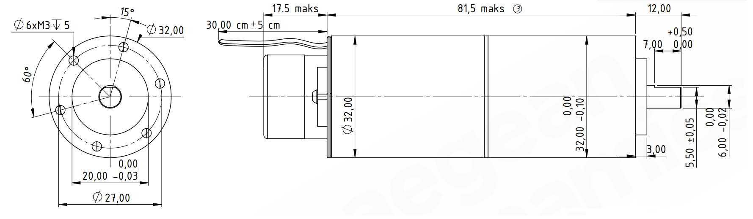
Basic Motor Parameters
Rated Power | W | 10
Rated Speed | rpm | 3100
Rated Torque | Nm | 0.030
Rated Current | A | 1.1
Rated Voltage | V | 12
No-Load Speed | rpm | 3600
Max. Efficiency | % | 80
Electrical Parameters
Number of Phases |  | 3
Number of Poles |  | 6
Torque Constant (KT) | Nm/A | 0.029
Back EMF Constant (KE) | Vs/rad | 0.032
Terminal Resistance Phase to Phase (±%10) | mΩ | 1.2
Terminal Inductance Phase to Phase (±%30) | mH | 0.80
Thermal Data
Ambient Temperature | °C | -40...+85
Max. Winding Temperature | °C | +155
Physical Parameters
Outer Diameter | mm | 32
Shaft Diameter | mm | 6
Max. Lenght | mm | ~111
Weight | gr | ~377
Motor Connection
U | RED CABLE
V | WHITE CABLE
W | BLACK CABLE
Sensor Connection
1 | VDC+
2 | GND
8 | CLK-
9 | CLK+
10 | DATA-
11 | DATA+
Connector Articles
Power | 0.24MM^2 cable
Signal | Molex 501330-1100

